

**Calvary**

**Connection**

**APRIL | VOLUME 2 | 2017**

**UPCOMING EVENTS**

Prayer Service April 5 6:30 PM

Good Friday Singing April 14 7 PM

Easter Program April 16

Billy Graham Museum April 18

Regional Bible Drill April 29

Mother's Day Tea May 6



**Meeting Times**

Sunday Fellowship 9:15 - 9:30 AM

Sunday School 9:30 AM

Sunday Worship 10:45 AM (Nursery and Kid's Worship)

Cantata Practice (Sun.) 4:00 PM

Women’s Study (Tues.) 10:00 AM

Bible Study (Wed.) 7:00 PM

Sidewalk Ministry (Wed.) 9:00 AM

Visitation (Thurs.) 9:30 AM

**Plans are now being made for VBS June 18-21. Pick up a volunteer form in the lobby if you are willing to help. i**

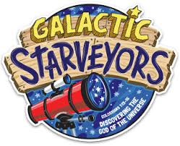

**Kids’ Worship Workers**

**4/02 Betty Jo Jones**

**4/09 Darlene Strickland**

**4/16 Delores Jones**

**4/23 Crystal Brayboy**

**4/30 Diane Jones**

Moddie Strickland is the contact person for scheduling facilities and church maintenance issues. **843.687.7197**

Calvary Connection **PRAYER**

Join us for a time of corporate prayer before Bible study on Wednesday, April 5 at 6:30.

First Annual Easter Gospel Sing

Friday, April 14 from 7-9 PM

* The Locklears
* Bobby Deal Family
* Carla and Redemption

**VICTOR’S CROWN –** An Easter Celebration on Sunday, April 16.

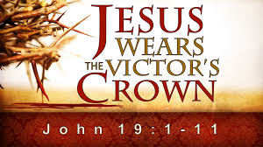

**ONE CALL NOW** - Make sure that you are getting important updates and messages from Calvary Way by giving your contact information to Betty Jones.



**PRAYER REQUESTS**

Please fill out a prayer request card at church if you have a special prayer concern, or email us directly at [prayer@calvarywaybaptist.org](mailto:prayer@calvarywaybaptist.org) with any requests or questions.

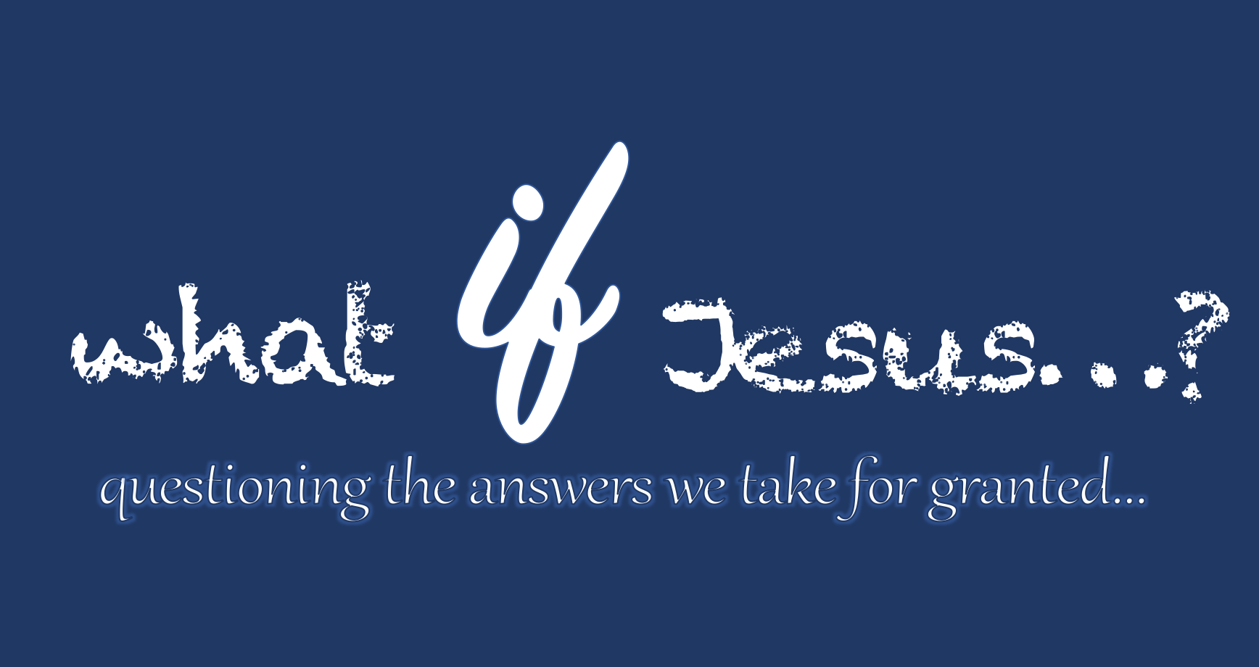

Regardless of what you may personally believe about Jesus, it would be very difficult to deny the impact His life and His teachings have had on the world.  There are also a lot of radical claims about Jesus.  As a matter of fact, in a few weeks, Christians will celebrate Easter, and the most radical claim of them all is that Jesus rose from the dead after being executed by the Romans.  This would be pretty astounding in any fictional novel; it would be downright earth-shattering if it really happened!  But…what if it did?  What if the things we’ve heard about Jesus really are true?  That’s what we want to explore at Calvary Way over these weeks leading up to Easter.  In ***What if Jesus…?*** , we want to explore truths about Jesus that are often dismissed or taken for granted.  Come and be challenged with us as we dig into the four big "IFs" concerning Jesus.

Calvary Way Baptist Church

208 North Main Street

P O Box 1748

Pembroke NC 28372

910.521.4114

[www.calvarywaybaptist.org](http://www.calvarywaybaptist.org)

<http://www.facebook/CalvaryWayChurch>

twitter@CalvaryWayCH

Instagram@CalvaryWayChurch

**CONNECT WITH US**

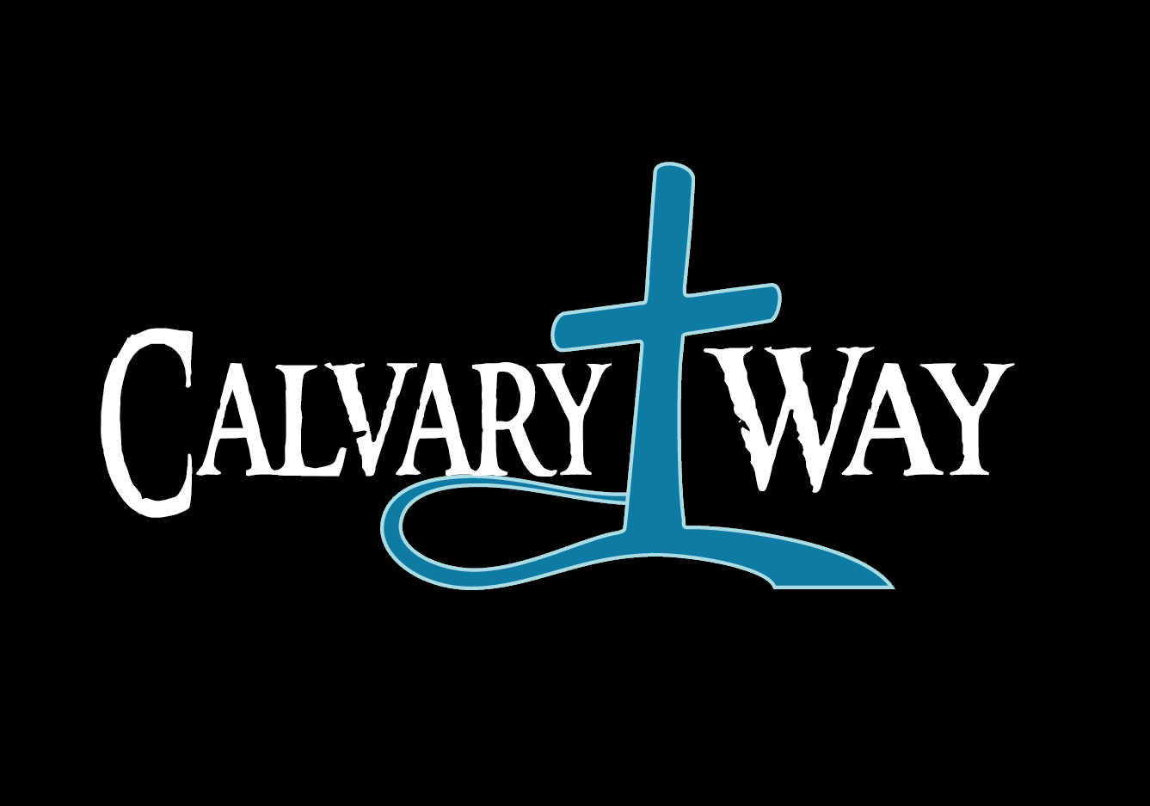

**March Offering Total: $13,888.00**

**Building Fund Total: $17,053.00**

Make a special contribution to the building fund in honor or in memory of someone (note on check -*Building Fund*).