UPCOMING EVENTS
Prayer Service June 7
VBS Kickoff - Star gazing June 10
VBS June 11-14
Father’s Day June 18
VBS Galactic Celebration June 18
Women’s Conference June 24
Calvary
Connection
June | VOLUME 3 | 2017

Calvary Connection PRAYER -
Join us for a time of corporate prayer before Bible study on Wednesday, June 7 at 6:30.

VBS 2017 - We want to turn our kids into Galactic Starveyors! As kids focus their telescopes on the marvels painted in the sky by the Creator, they will discover the wonder among all wonders - that the God who created everything there is - the knowable and the unknowable, the visible and the invisible - wants a personal relationship with them!

Dundarrach Women’s Conference Theme: God Is Able
Saturday, June 24: 8am BREAKFAST, 9am Program
Speakers - Sisters Doris Brooks, Dori West and Nell Locklear
JUNE SERMON SERIES
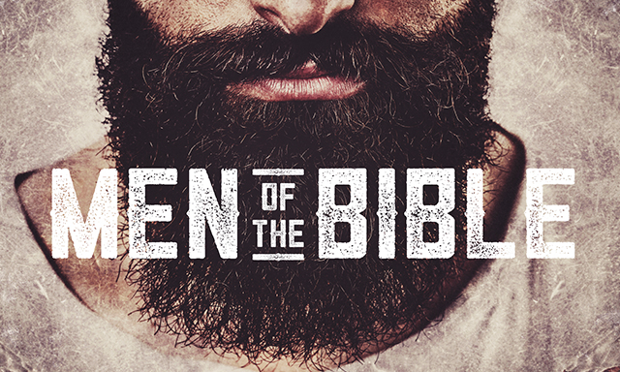
Week 1 – 6/04/2017
Samson - Judges 16
Controlling Ungodly Desires

Week 2 – 6/11/2017
Benaiah - 2 Samuel 23:20-21
The Call to Courage

Week 3 – 6/18/2017
VBS Wrap-up
Colossians 1:15-16
Discovering the God of the Universe

Week 4 – 6/25/2017
Daniel - Daniel 6
The Importance of Integrity

Week 5 – 7/02/2017
Peter - Luke 22:54-62
Flighty Faith

Wednesday Night Bible Studies
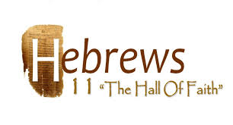
Meeting Times
Sunday Fellowship 9:15–9:30 AM
Sunday School 9:30 AM
Sunday Worship 10:45 AM
(Nursey and Kid’s Worship)
Women’s Study (Tues.)10:00 AM
Bible Study (Wed.) 7:00 PM
Sidewalk Ministry (Wed.) 9:00 AM
Visitation (Thurs.) 9:30 AM
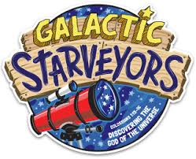
Moddie Strickland is the contact person for scheduling facilities and church maintenance issues. 843.687.7197
Kids’ Worship Workers
6/04 Betty Jo Jones
6/11 Darlene Strickland
6/18 Delores Jones
6/25 Crystal Brayboy

Kyla Elizabeth Dial
Lester Locklear

CONNECT WITH US

Calvary Way Baptist Church
208 North Main Street
P O Box 1748
Pembroke NC 28372
910.521.4114
www.calvarywaybaptist.org
http://www.facebook/CalvaryWayChurch
twitter@CalvaryWayCH
Instagram@CalvaryWayChurch

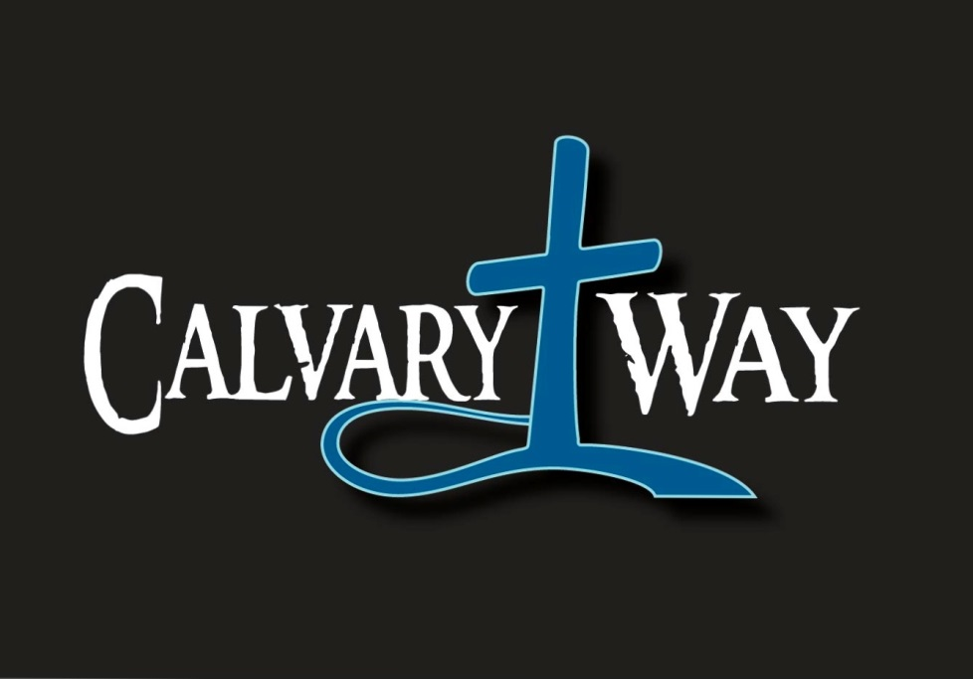

June
Date | Acts | Chapter
1 |  | 10
2 |  | 11
3 | Reflection
4 | Reflection
5 |  | 12
6 |  | 13
7 |  | 14
8 |  | 15
9 |  | 16
10 | Reflection
11 | Reflection
12 |  | 17
13 |  | 18
14 |  | 19
15 |  | 20
16 |  | 21
17 | Reflection
18 | Reflection
19 |  | 22
20 |  | 23
21 |  | 24
22 |  | 25
23 |  | 26
24 | Reflection
25 | Reflection
26 |  | 27
27 |  | 28
 | Hebrews
28 |  | 1
29 |  | 2
30 |  | 3
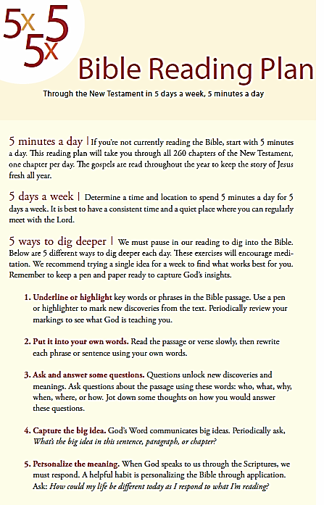
Calvary Connection Read

CALVARY CONNECTION FAMILY
Use the following questions, related to each week’s Gospel Project lesson, to have one spiritual conversation with your family.

6/04 What takeaways can our family gain from Jesus’ parable of the sower and the soils and its explanation?
6/11 Discuss the importance of realizing how great our debt to God was, and how we could never repay it, so Jesus repaid it
for us.
6/18 What are some practical ways our family can show compassion to people in need?
6/25 How is our family sometimes tempted to focus on the good deeds we do rather than our relationship with God?

